Guide to using the Coronovirus Dashboard
https://coronavirus.data.gov.uk/
The landing page contains a UK Summary.

To access Testing, Cases, Healthcare and Deaths data, use the menu on the left hand side.
Clicking on each of those will bring up the National Stats for each one. At the top of each of these pages will be a drop down option next to, for example, Cases in United Kingdom. When you click on the drop down, you can select if you would like to know the information for Nations, Regions or Local Authorities. Make your selection and the relevant data will be shown.

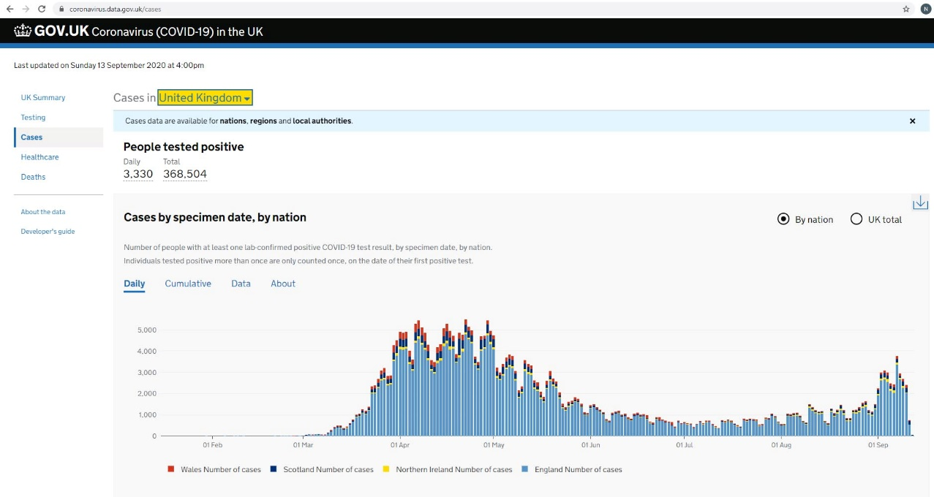

Alternatively, if you scroll down, you will find the Cases by Local Area in England box with a link to a map. Click on “View Map” and it will take you to a new page where you can click on a specific area like SWF and it will tell you the number of confirmed cases for SWF.

